Consider the Following Tables.

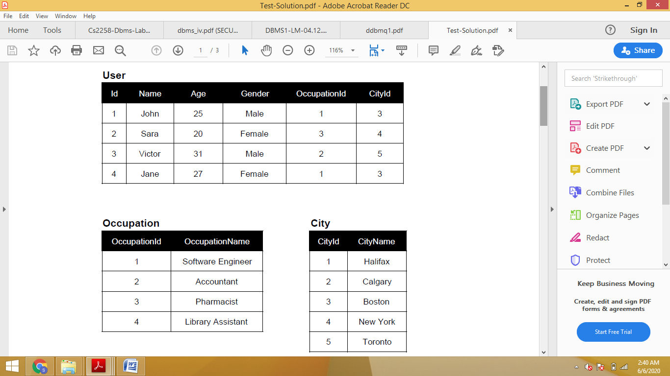

**Write down the SQL statements for Above Scenarios.**

For the above schema, perform the following

1. Create the tables with the appropriate integrity constraints at table level.
2. Rename any table name.
3. Write a query to display the age, name where the age is greater than 20.
4. Display the name of all users where the second letter of the name is **a**.
5. Write a query to display the age, id where the age is not equal to 31 and id is greater than 2.
6. Create a query to display the name concatenated with the gender, separated by comma and space. Name the column heading USER_DETAILS respectively.
7. Display the name of all occupation where the last letter of the occupationname is **t**.
8. Display the city name of all citiess where the second letter of the cityname is **o**.
9. Confirm that the constraints were added by querying the User_Constraints view.
10. Add a comment to the User table and also confirm your addition in the data dictionary.